docker login -u apalumbo925

enter in your password

docker login cp.icr.io -u cp -p ****

docker pull [cp.icr.io/cp/appc/ace-server-prod@sha256:c1fac1a80768e26f64d8fff770b10a96b99b2bd4df2e2cd533e96f1a85ebec5c](mailto:cp.icr.io/cp/appc/ace-server-prod@sha256:c1fac1a80768e26f64d8fff770b10a96b99b2bd4df2e2cd533e96f1a85ebec5c)

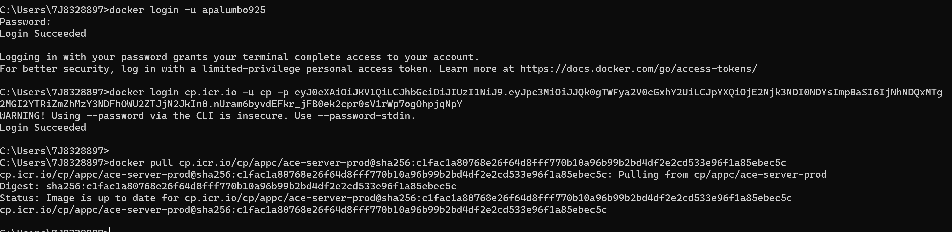

Re tag the image

docker tag cp.icr.io/cp/appc/ace-server-prod@sha256:c1fac1a80768e26f64d8fff770b10a96b99b2bd4df2e2cd533e96f1a85ebec5c apalumbo925/acetektonpipeline_example:latest

push the image to dockerhub or local repo

docker push apalumbo925/acetektonpipeline_example:latest

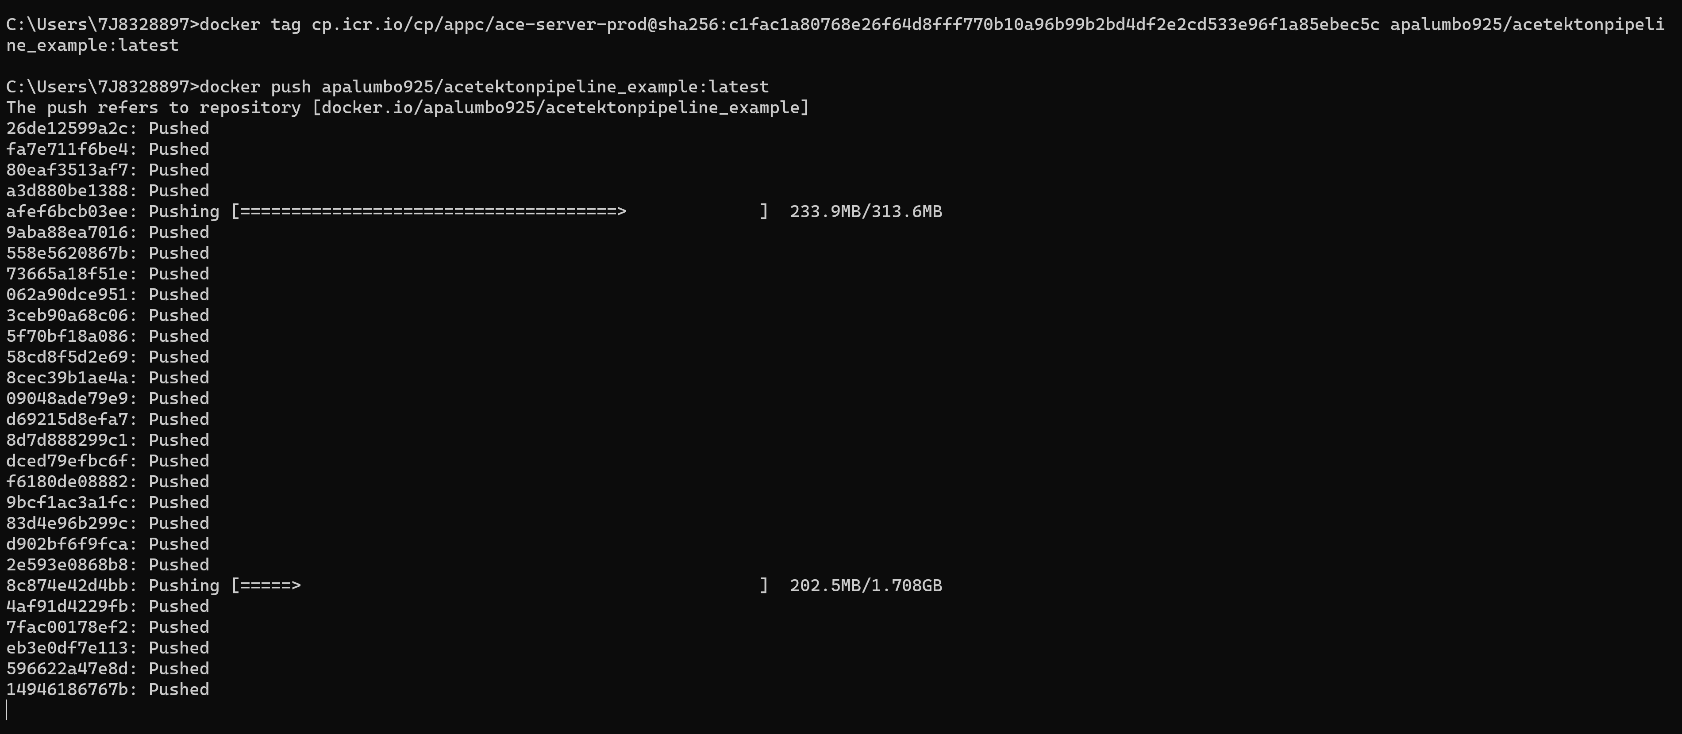

docker run -e LICENSE=accept -p 7600:7600 -p 7800:7800 -p 7843:7843 --name aceserver apalumbo925/acetektonpipeline_example

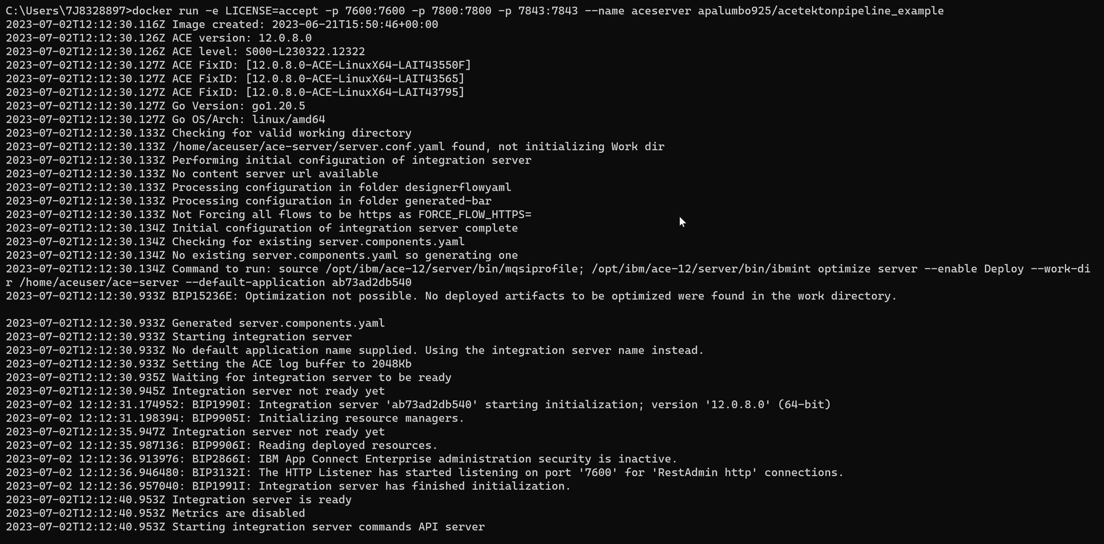

Okay Next steps

Make a new directory

Change into that directory   
  
git clone from your repo / my repo the yaml files for the example pipeline or follow the example yamls and substitute the different variables and parameters for your current applications / projects   
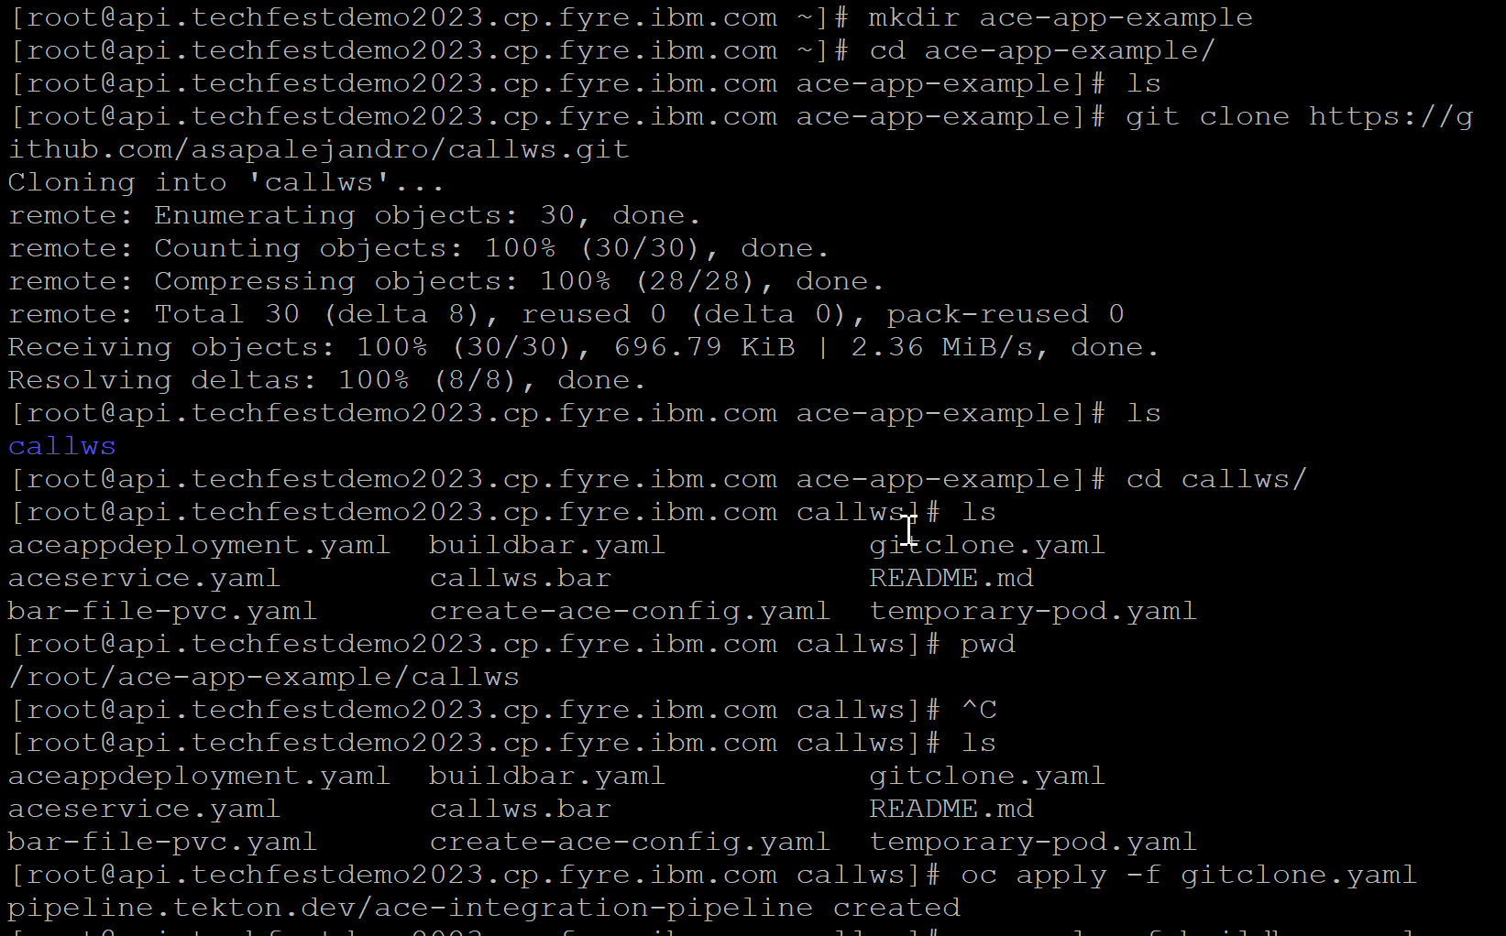

Apply the git clone yaml task and tekton should create this pipeline   
  
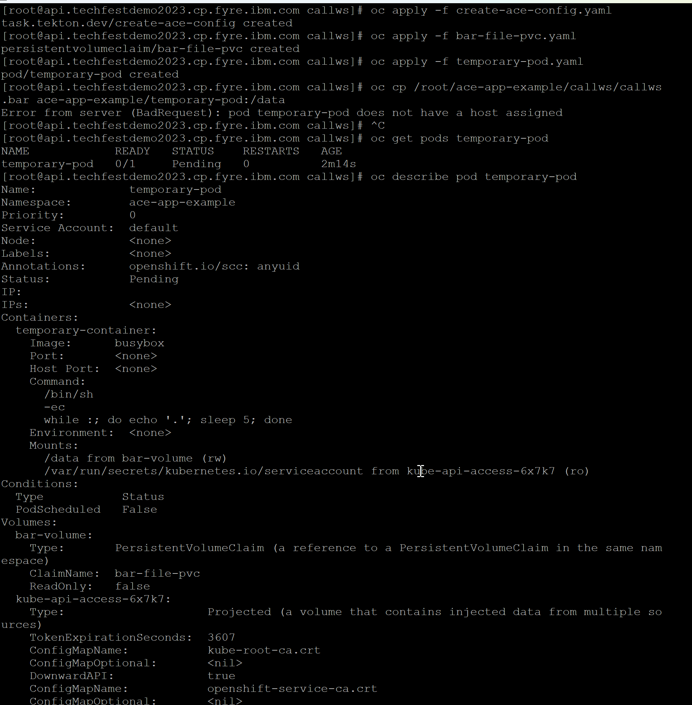

We then oc apply our different yamls / tasks and pvcs needed

So whats happening here is our tekton ace config task is created,

We then create a pvc for our bar file so that it will be persistently stored and mounted on the pods its run on and don’t have to keep manually applying it   
we create a temporary pod to copy over the bar file and mount it onto the mount   
  
I had to troubleshoot this portion a little because my pods were schedulable but your cluster should be fine   
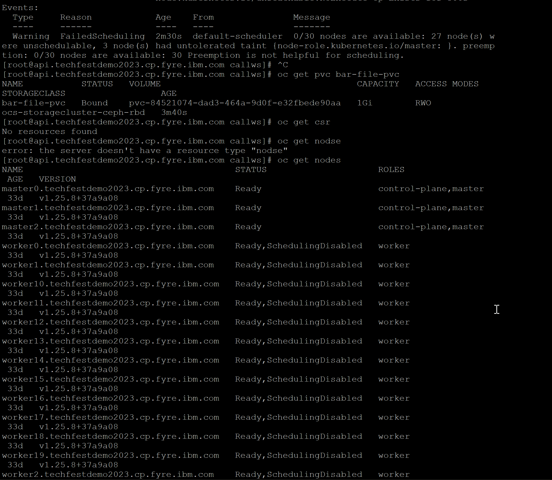  
  
The key portion on this screen shot is checking the oc get pvc bar-file-pvc to see that it is bound  
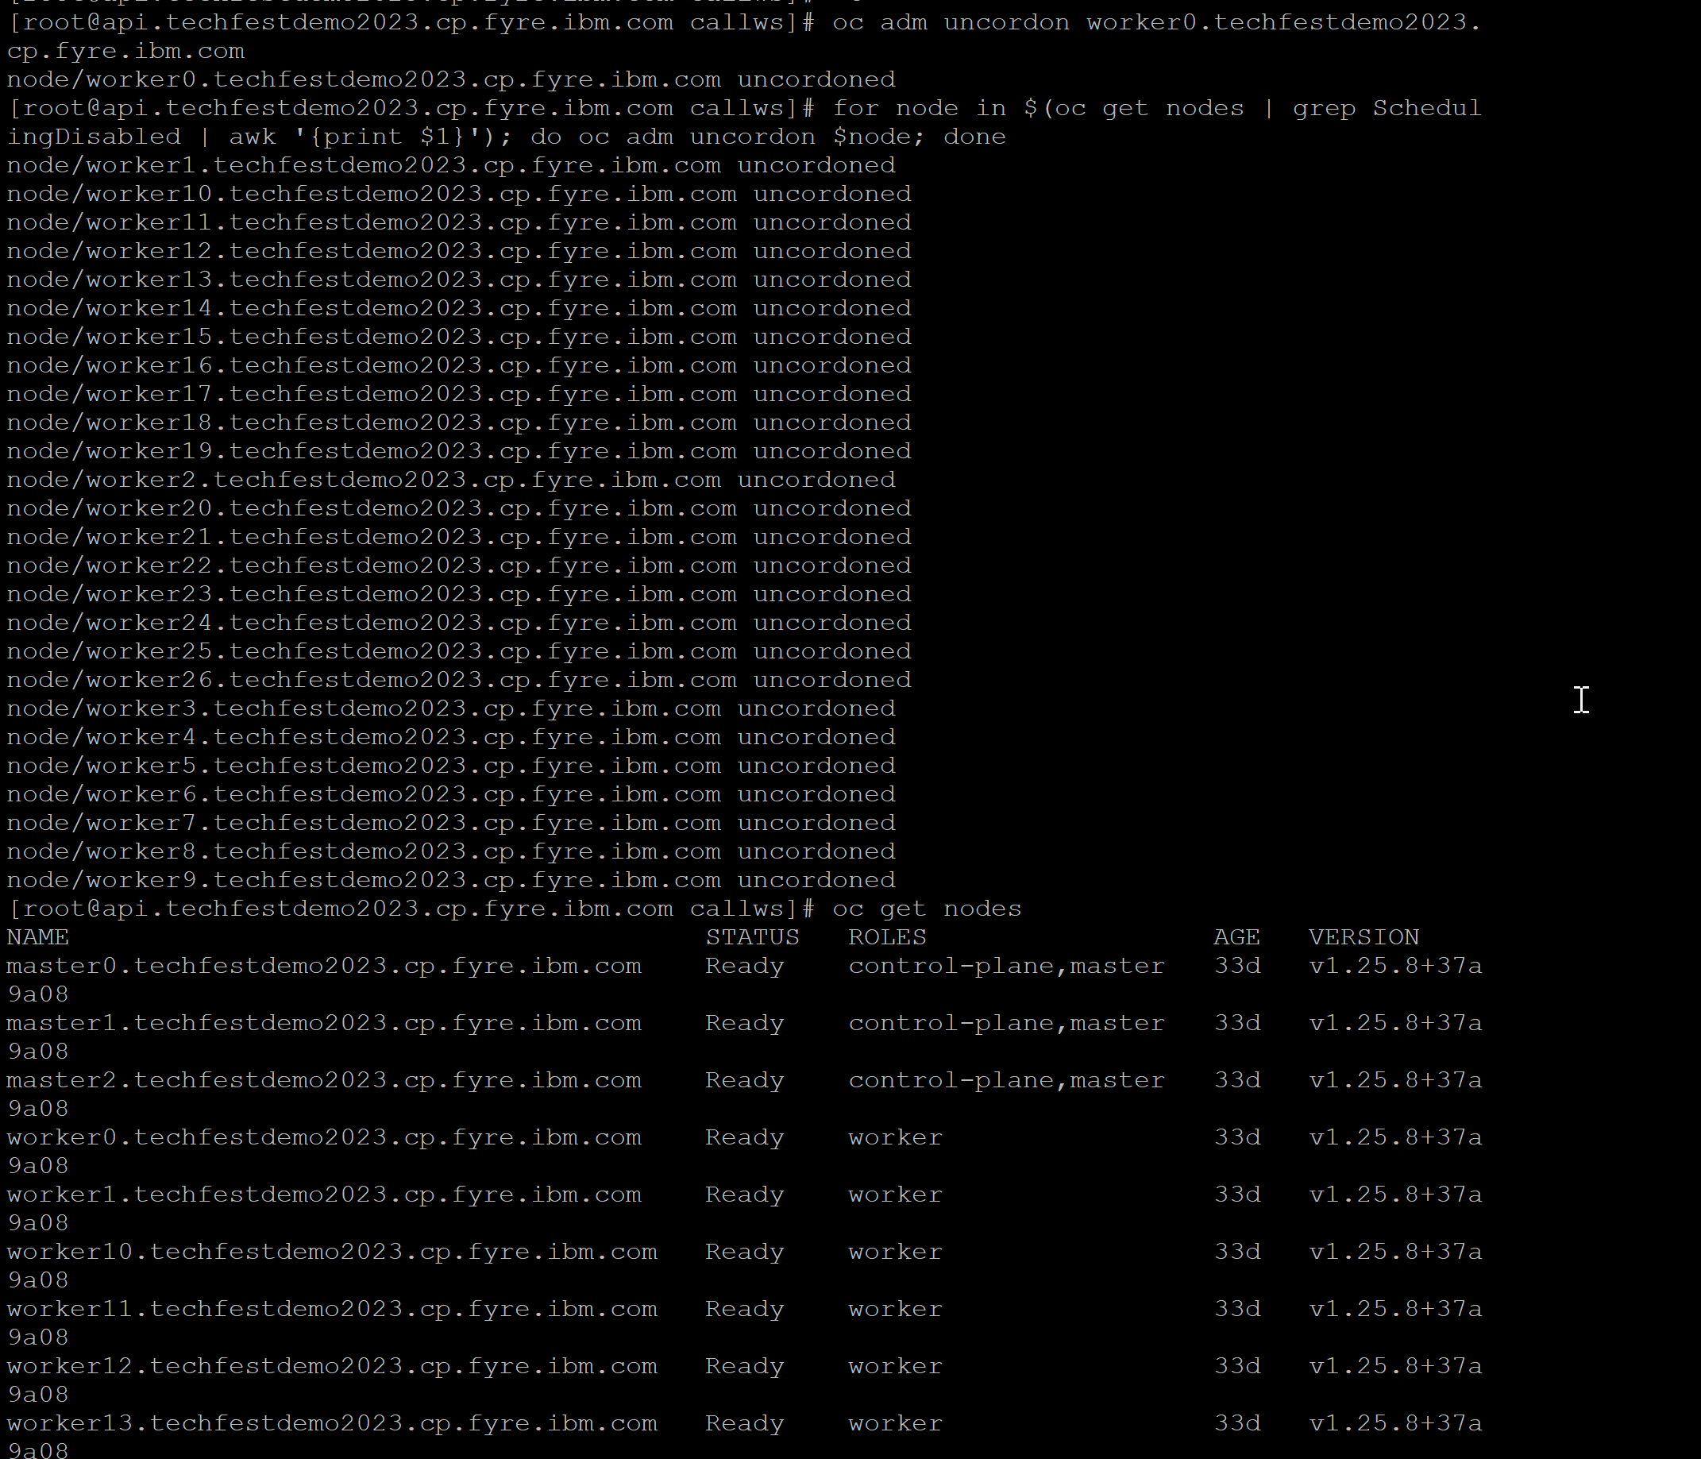  
  
Part of the troubleshooting you can ignore this is I had to uncordone my nodes I did one manually and then wrote a for loop for the rest

oc cp path/to/your/file.bar ace_app_example/temporary-pod:/data  
  
  
  
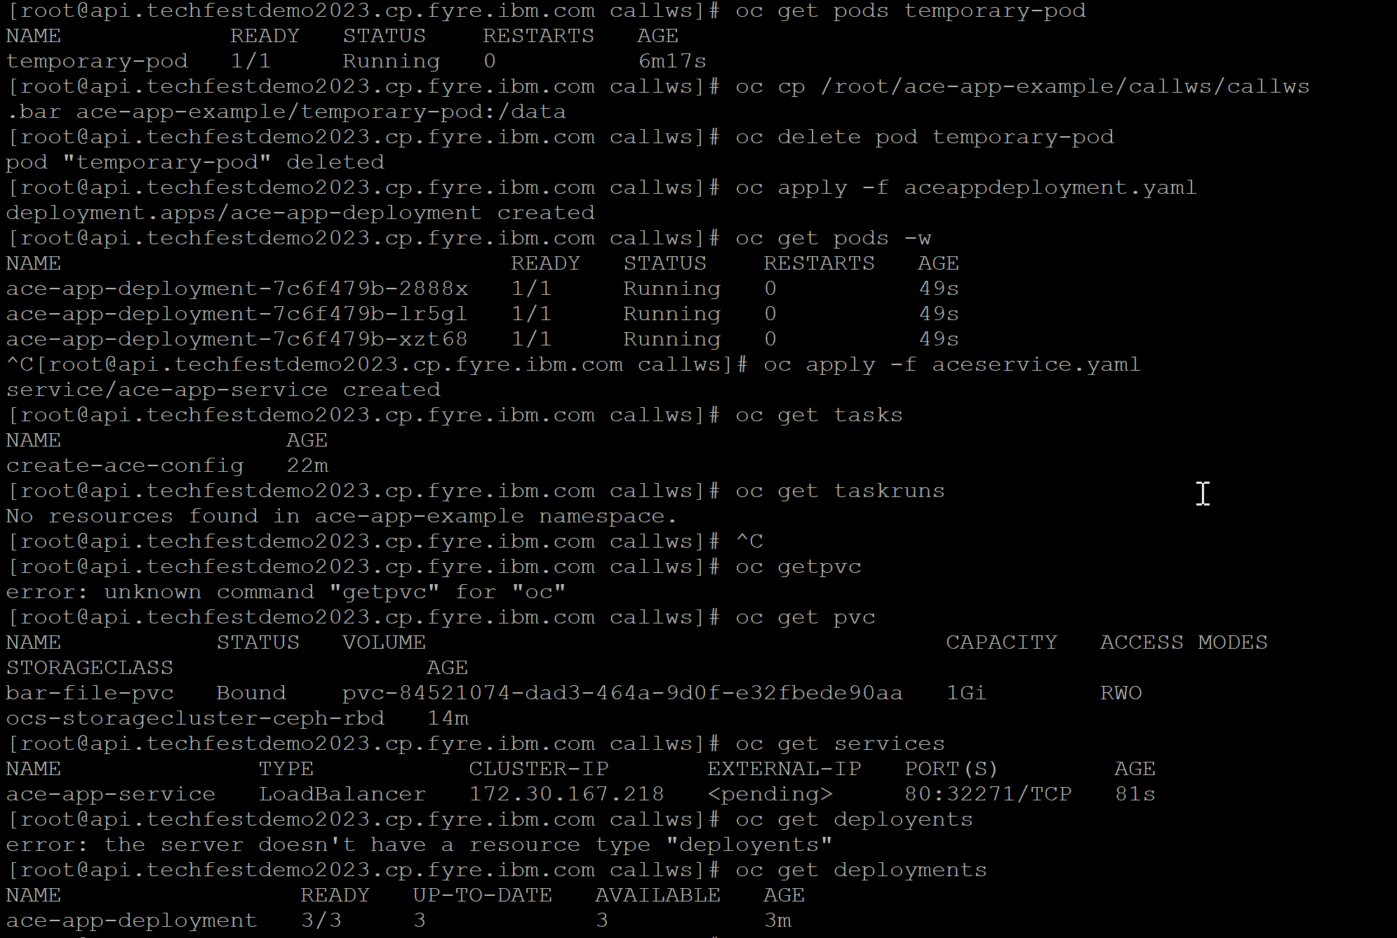

So now that our pods can be scheduled check that the temporary pod is up and then copy over the bar file and mount it to data on the pod

oc cp /root/ace_tekton_app_example/callws/output/callws.bar ace_app_example/temporary-pod:/data

you can then delete the temporary pod we just wanted the bar file mounted   
  
apply the next deployment (We are testing this later once everything is confirmed we will edit this to create a task and add it as part of our tekton pipeline   
  
So now our ace application deployment is done and 3 pods should be created

apply the load balancer service (ace service) to expose our application   
  
we then check on our

pods

tasks   
 pvcs  
services   
deployments

Everything looks good to go   
  
so now we   
apply-deployment-task.yaml,   
ace-integration-pipeline.yaml,   
pipelinerun.yaml

in that order for everything to work correctly.  
  
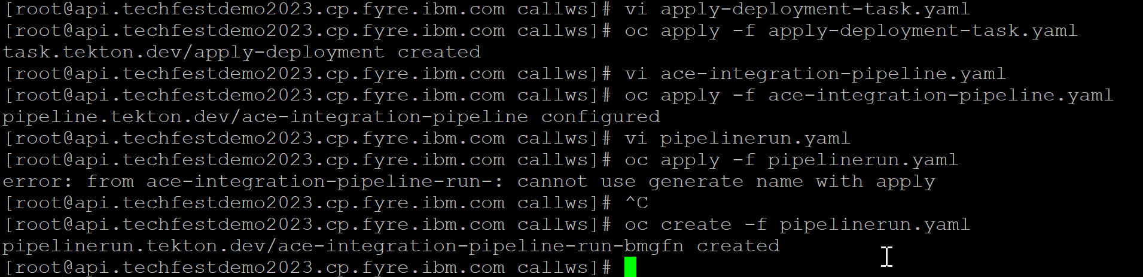

And Tada our pipeline was created!